

# 

### Semester Two Examination, 2018

### Question/Answer booklet

# MATHEMATICS

If required by your examination administrator, please place your student identification label in this box

**METHODS**

**UNITS 3 AND 4**

## Section One:

## Calculator-free

|  |  |  |  |  |  |  |  |  |  |  |
| --- | --- | --- | --- | --- | --- | --- | --- | --- | --- | --- |
| Student number: In figures |  |  |  |  |  |  |  |  |  |  |

In words

Your name

## Time allowed for this section

Reading time before commencing work: five minutes

Working time: fifty minutes

## Materials required/recommended for this section

***To be provided by the supervisor***

This Question/Answer booklet

Formula sheet

***To be provided by the candidate***

Standard items: pens (blue/black preferred), pencils (including coloured), sharpener,  
correction fluid/tape, eraser, ruler, highlighters

Special items: nil

## Important note to candidates

No other items may be taken into the examination room. It is **your** responsibility to ensure that you do not have any unauthorised material. If you have any unauthorised material with you, hand it to the supervisor **before** reading any further.

## Structure of this paper

|  |  |  |  |  |  |
| --- | --- | --- | --- | --- | --- |
| Section | Number of questions available | Number of questions to be answered | Working  time (minutes) | Marks available | Percentage of examination |
| Section One:  Calculator-free | 8 | 8 | 50 | 52 | 35 |
| Section Two:  Calculator-assumed | 13 | 13 | 100 | 98 | 65 |
|  | | |  | **Total** | 100 |

|  |  |  |
| --- | --- | --- |
| Markers use only | | |
| Question | Maximum | Mark |
| 1 | 6 |  |
| 2 | 5 |  |
| 3 | 7 |  |
| 4 | 6 |  |
| 5 | 6 |  |
| 6 | 8 |  |
| 7 | 6 |  |
| 8 | 8 |  |
| S1 Total | 52 |  |
| S1 Wt (×0.6731) | 35% |  |
| S2 Wt | 65% |  |
| Total | 100% |  |

## Instructions to candidates

1. The rules for the conduct of examinations are detailed in the school handbook. Sitting this examination implies that you agree to abide by these rules.

2. Write your answers in this Question/Answer booklet.

3. You must be careful to confine your response to the specific question asked and to follow any instructions that are specified to a particular question.

4. Supplementary pages for the use of planning/continuing your answer to a question  
have been provided at the end of this Question/Answer booklet. If you use these pages to continue an answer, indicate at the original answer where the answer is continued, i.e. give the page number.

5. Show all your working clearly. Your working should be in sufficient detail to allow your answers to be checked readily and for marks to be awarded for reasoning. Incorrect answers given without supporting reasoning cannot be allocated any marks. For any question or part question worth more than two marks, valid working or justification is required to receive full marks. If you repeat any question, ensure that you cancel the answer you do not wish to have marked.

6. It is recommended that you do not use pencil, except in diagrams.

7. The Formula sheet is not to be handed in with your Question/Answer booklet.

Section One: Calculator-free 35% (52 Marks)

This section has**eight (****8)** questions. Answer **all** questions. Write your answers in the spaces provided.

Working time: 50 minutes.

Question 1 (6 marks)

The shaded region $R$, shown on the graph below, is bounded by the curve $y=e^{3x}$ and the lines $y=0, x=0$ and $x=a$.

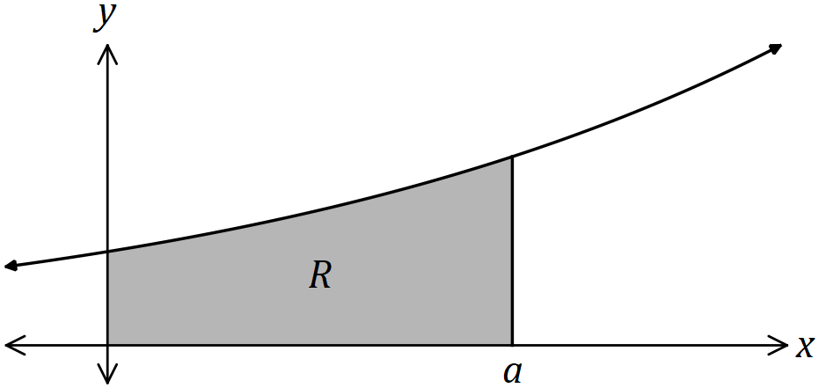

(a) Determine the area of $R$ in terms of $a$. (3 marks)

(b) Determine, in simplest form, the value of $a$ for which the area of $R$ is $21$ square units.

(3 marks)

Question 2 (5 marks)

(a) Simplify $\log_{2}{(16)}÷\log_{5}{({125}^{2})}$. (2 marks)

(b) Solve the equation $\ln{(4-x)}+\ln{2}=2\ln{x}$. (3 marks)

Question 3 (7 marks)

The graph of $y=2x^{2}e^{-x}$ has one local minimum and one local maximum.

(a) Determine the $x$ ­­­­-coordinates of the stationary points of the graph. (3 marks)

(b) Use the second derivative test to determine which of the points from (a) is a local maximum and state the coordinates of this point. (4 marks)

Question 4 (6 marks)

The random variable $X$ has probability density function

$$f\left(x\right)=\left\{\begin{matrix}k{\left(\frac{x}{4}-1\right)}^{3}, & 4≤x≤12 \\ 0, & \text{elsewhere.}\end{matrix}\right.$$

(a) Determine the value of the constant $k$. (4 marks)

(b) Write down the cumulative distribution function $F\left(t\right)=P(X≤t)$ for $4≤t≤12$ and hence determine $P(X≤8)$. (2 marks)

Question 5 (6 marks)

(a) Determine the anti-derivative of $\begin{matrix}\cos{(3x)} \\ \overline{5+\sin{(3x)}}\end{matrix}$. (2 marks)

(b) Determine $f^{'}\left(x\right)$ when $f\left(x\right)=2x\ln{(5x)}.$ (2 marks)

(c) Evaluate $\int_{0.2}^{1}{\underset{ }{\overset{ }{\left(2 ln{(5x)}+2\right)}}}dx$. (2 marks)

Question 6 (8 marks)

Right-triangle $T$ has vertices $\left(0, 0\right), (p, 0)$ and $\left(0, q\right)$ where $p>3$ and $q>5$.

The straight line from $(p, 0)$ to $(0, q)$ passes through the point $(3, 5)$.

(a) Sketch a diagram to show this information. (1 mark)

(b) Show that the area of the triangle is $\begin{matrix}5p^{2} \\ \overline{2(p-3)}\end{matrix}$. (3 marks)

(c) Determine the value of $p$ that minimises the area of the triangle and state the minimum area. (4 marks)

Question 7 (6 marks)

The time, $t$ years, to repay a loan of $\$57 000$ at $8.4\%$ interest with monthly repayments of $x$ dollars can be approximated by

$$t=12\ln\left(\frac{x}{x-400}\right), x>400$$

(a) Determine the time to repay the loan when the monthly repayment is $\$600$, simplifying your answer. (1 mark)

(b) Use the increments formula to estimate the time saved in repaying the loan if the monthly repayment of $\$600$ is increased by $5\%$. (5 marks)

Question 8 (8 marks)

(a) Sketch the graph of $y=\log_{4}{(x-2)}+1$ on the axes below, clearly showing the location of all asymptotes and axes intercepts. (3 marks)

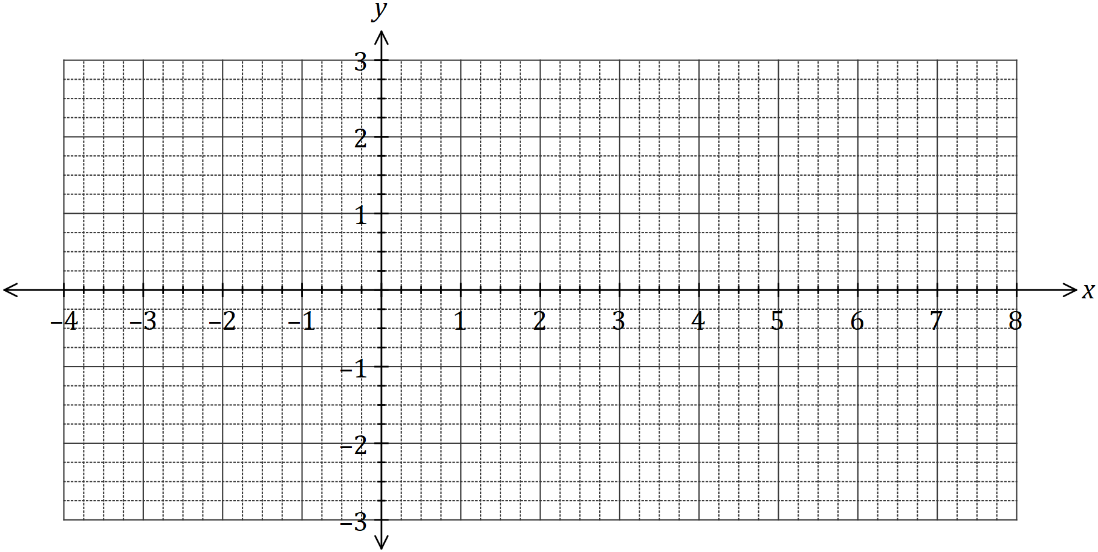

(b) Determine the coordinates of the $y$-intercept of the graph of $y=5-\log_{2}{(x+0.125)}$.

(2 marks)

(c) The graph of $y=\log_{a}{(x-a)}$, where $a>1$, passes through $(8.75, 2)$. Determine the coordinates of the root of the graph. (3 marks)

Supplementary page

Question number: _________

© 2018 WA Exam Papers. Kennedy Baptist College has a non-exclusive licence to copy and communicate this document for non-commercial, educational use within the school. No other copying, communication or use is permitted without the express written permission of WA Exam Papers. SN245-125-1.